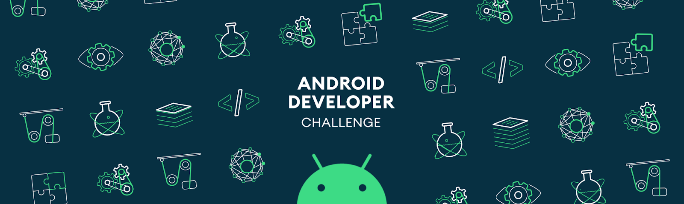

*Please make a copy of this document and include this in your GitHub repository for your submission, using the tag #AndroidDevChallenge*

Tell us what your idea is.

Describe in 250 words what the feature or service will do and how you’ll use Machine Learning to push the bar:
Application Installation Scanner : With this feature we plan to make the android application installation hassle free for the android users.
The idea is basically to recognize the application from another device with the help of application logo.
The plan is basically to built an applciation(or feature on the Google Play Store) that with the help of the device camera will scan the application from another device.
The application scanning will include the following :
- Creating a Bitmap of the application logo in miniature form for image search on the Google.
- Recognizing the application name/title form the line just below the icon
- Building a custom ui overlay in which the user will have to point the application logo for exact scanning.
For Bitmap miniature creation we will be using the camera graphic overlay class and then scanning with that. When completely scanned we will search it simply on the Google website. From the list of results priovided by the Google we will identify the applciation play store link and will redirect the user to the same.
Before we redirect the user to the Google Play store page, we will use the applciation title/name scanned with the help of Firebase Text Detection utility from the firebase ML kit.
We will then verify the applciation title mentioned on the Google Play Store to ensure that the link is correct and not just a result from the similar image as a result of the image search SEO score.

Tell us how you plan on bringing it to life.

Describe where your project is, how you could use Google’s help in the endeavor, and how you plan on using On-Device ML technology to bring the concept to life. The best submissions have a great idea combined with a concrete path of where you plan on going, which should include:
- (1) any potential sample code you’ve already written,
- (2) a list of the ways you could use Google’s help,
- (3) as well as the timeline on how you plan on bringing it to life by May 1, 2020.
The project is currently only an idea.
We will need following helps/advices from the Google developers :
- Direct Installtation from our application/feature when the user navigates to an application or an Api to perform something similar
- A direct Utility/ Api to compare the logos of the application with the scanned logo would be much helpful.

TimeLine :
Decemeber 2019 : Image detection, Text detection and Bitmap miniature creation for Google Search
January 2020 : Search Image on Google and work on the optimization of the image search results.
Feburary 2020 : Work on fetching the application details from the Google play Store and verifying the results from image search.
March 2020 : Text verification for accurate results using the application title as scanned.
April 2020: Quality analyst of the work done under various crucial situations and optimizations, finally publishing the application on Google Play Store.

Tell us about you.

A great idea is just one part of the equation; we also want to learn a bit more about you. Share with us some of your other projects so we can get an idea of how we can assist you with your project.

We have two members in our team.
Ayushi Agarwal :
This is Ayushi Agarwal. I'm currently working as Software Engineer in Webkul Noida. I have total 3.5 year experience in Android App Development. I have working experience on E-Commerce and ERP based applications. I have worked on diiferent Android Architecture. Main focus is to make things which can make android-user life easy.
I always try to enhance my coding style. I have experience on diiferent Android Architecture like MVC-MVP-MVVM, dependency injection framework like Dagger, concurrency style like Coroutines, Unit test cases with code coverage.

Anchit Makkar :
Hi, My Name is Anchit Makkar.
I have been working on Android since September,2016 for Webkul (Indian Bootstrap E-Commerce Pioneer Company) providing extensions and plugins for various ecommerce platforms since the last decade.
Most of my work have been majorly around ecommerce application development and restful APIs.
You can see some of my articles for helping the community and novice android developers over here: https://mobikul.com/author/anchit-makkar849webkul-com/
Next steps.

- Be sure to include this cover letter in your GitHub repository
- Your GitHub repository should be tagged #AndroidDevChallenge
- Don’t forget to include other items in your GitHub repository to help us evaluate your submission; you can include prior projects you've worked on, sample code you've already built for this project, or anything else you think could be helpful in evaluating your concept and your ability to build it
- The final step is to fill out this form to officially submit your proposal.

